**Pizza Sales SQL Queries**

KPIs

1. **Total Revenue:**

SELECT SUM(total_price) AS 'Total Revenue' FROM pizza_sales;

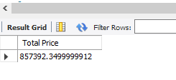

1. **Average Order Value:**

SELECT SUM(total_price)/COUNT(DISTINCT order_id) as ‘Average Order Value’ FROM pizza_sales;

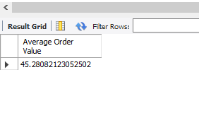

1. **Total Pizzas Sold:**

SELECT SUM(quantity) AS 'Total Pizza Sold' FROM pizzadb.pizza_sales;

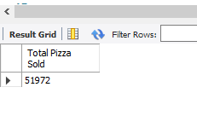

1. **Total Orders:**

SELECT COUNT(DISTINCT order_id) AS 'Total Orders' FROM pizzadb.pizza_sales;

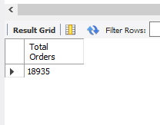

1. **Average Pizzas Sold Per Order:**

SELECT SUM(quantity)/COUNT(DISTINCT order_id) AS 'Average Pizzas Sold' FROM pizzadb.pizza_sales;

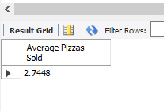

1. **Hourly Trend For Total Pizzas Sold:**

SELECT HOUR(order_time) AS order_hour, SUM(quantity) AS 'Total Pizzas Sold' FROM pizzadb.pizza_sales

GROUP BY HOUR(order_time) ORDER BY HOUR(order_time);

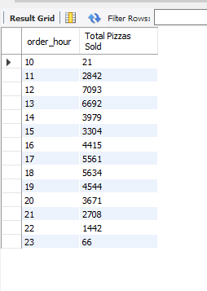

1. **Weekly Trend for total Orders:**

SELECT WEEK(order_date,3) AS week_number,YEAR(order_date) AS Order_year,

COUNT(DISTINCT order_id) AS Total_orders FROM pizza_sales

GROUP BY WEEK(order_date,3),YEAR(order_date)

ORDER BY WEEK(order_date,3),YEAR(order_date);

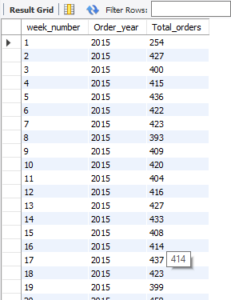

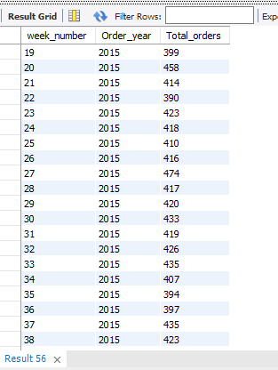

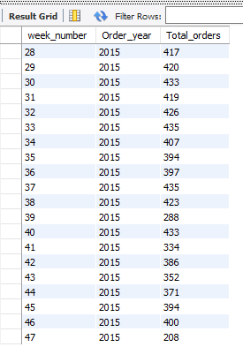

1. **Percentage of Sales by Pizza Category:**

SELECT pizza_category,ROUND(SUM(total_price),2) AS 'Total Sales',

ROUND(SUM(total_price)/(SELECT SUM(total_price) FROM pizza_sales)*100,2) AS 'percentage_of_sales'

FROM pizza_sales GROUP BY pizza_category;

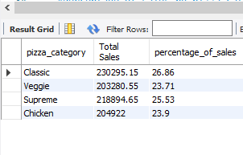

1. **Percentage of sales by pizza size:**

SELECT pizza_size, ROUND((SUM(total_price)*100)/(SELECT SUM(total_price) FROM pizza_sales),2) AS 'percentage_of_sales' FROM pizza_sales

GROUP BY pizza_size;

SELECT *FROM pizza_sales;

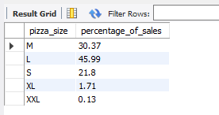

1. **Top 5 best selling pizzas base on revenue, total quantity and total orders.**

SELECT pizza_name,ROUND(SUM(total_price),2) AS 'Revenue'

FROM pizza_sales GROUP BY pizza_name

ORDER BY Revenue DESC LIMIT 5;

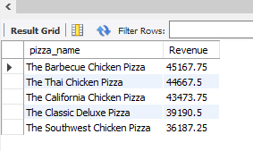

SELECT pizza_name,SUM(quantity) AS 'Total_quantity'

FROM pizza_sales GROUP BY pizza_name

ORDER BY Total_quantity DESC LIMIT 5;

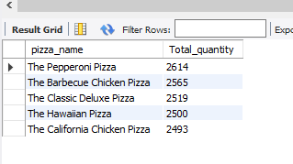

SELECT pizza_name, COUNT(DISTINCT order_id) AS 'Total_orders' FROM pizza_sales GROUP BY pizza_name ORDER BY Total_orders DESC LIMIT 5;

